
TN SKILLS PROJECT
DEPARTMENT OF COMPUTER SCIENCE
ALPHA ARTS AND SCIENCE COLLEGE
PORUR, CHENNAI
(Reaccredited by NAAC and Affiliated to University of Madras)

PROJECT TITLE:
AI-Augmented Backend Development
AI FAQ Assistant API

TEAM DETAILS:
TEAM LEADER: Keerthana S
NM ID: 594359CAF62F242B63B4AC3DD8D2DB05
TEAM MEMBER: Nandhini A
NM ID: 324ED435102A3BAA7764A620B6E6A51E
TEAM MEMBER: Tamizharasu P
NM ID: 324ED435102A3BAA7764A620B6E6A51E
TEAM MEMBER: Shamini S
NM ID: 64656147A2D71B08FDB4B09E98754E88

OBJECTIVE:
The main objective of the AI-powered FAQ and Customer Support Automation
system is to develop a secure and intelligent backend API that automates FAQ
creation, management, searching, and customer support operations.
The project aims to:
1. Develop a RESTful API using Node.js and Express.js for managing FAQ
and user-related operations.
2. Store and manage user and FAQ information efficiently using MongoDB
and Mongoose.
3. Provide secure user authentication and authorization using JWT and
bcrypt.
4. Automate FAQ generation using Google Gemini AI to create relevant
questions, answers, and topic suggestions.
5. Provide keyword and semantic search to help users find relevant FAQ
information quickly.
6. Implement complete CRUD operations for creating, viewing, updating, and
deleting FAQ records.
7. Organize FAQs into categories for easy management and navigation.
8. Maintain data integrity and security through schema validation, protected
routes, and centralized error handling.
9. Reduce manual effort and improve the efficiency of customer support and
FAQ management.

PLATFORM AND TECHNOLOGY USED:
The following platforms and technologies are used to develop the AI-powered
FAQ and Customer Support Automation system:
Platform /
Usage
Technology
Node.js Used as the runtime environment for the backend server.
Express.js Used to develop the RESTful API and handle routing.
Used as the primary NoSQL database for storing users and
MongoDB
FAQ data.
Used for database modeling, schema validation, and
Mongoose communication with MongoDB.
Used for AI-powered FAQ generation and automated
Google Gemini AI question-answer creation.
Used as the main programming language for backend
JavaScript development.
JWT (JSON Web
Used for user authentication and authorization.
Token)
bcrypt Used for securely hashing user passwords.

Postman /
Used for testing and verifying API endpoints.
ThunderClient
Visual Studio Code
Used as the code editor and development environment.
npm Used for installing and managing project dependencies.
IMPLEMENTATION / PROCESS
The implementation of the AI-powered FAQ and Customer Support
Automation system is carried out through the following steps:
1. Project Setup
A project folder is created and opened in Visual Studio Code. A src folder is
created to organize the backend source files. Node.js and npm are used to
initialize the project and install the required dependencies.
2. Backend Server Development
Node.js and Express.js are used to develop the backend server. The Express
server handles HTTP requests such as GET, POST, PUT, and DELETE and
provides RESTful API endpoints.
3. Database Configuration
MongoDB is configured as the main database. Mongoose is used to create
schemas, validate data, and communicate between the application and
MongoDB.
4. User Authentication and Security
JWT is implemented for authentication and authorization. Passwords are

securely hashed using bcrypt. Middleware is used to protect private API
routes and verify authenticated users.
5. FAQ Management
FAQ records are created with details such as question,
6. answer, category, and creator information. CRUD operations are
implemented to create, read, update, and delete FAQ records.
7. AI Integration
Google Gemini AI is integrated into the backend to automatically generate
FAQ questions, answers, and topic suggestions based on the given topic.
8. Search and Category Management
Users can search FAQs using keywords. FAQs are organized into categories
to make information easier to manage and retrieve.
9. Error Handling and Validation
Centralized error handling and Mongoose schema validation are
implemented to maintain data integrity and provide standardized API
responses.
10.API Testing
Postman or ThunderClient is used to test the API endpoints. Registration,
login, FAQ creation, FAQ search, and AI-powered FAQ generation are
verified using appropriate requests and JSON data.
11.Execution
The backend development server is started using the npm development
command. The API endpoints can then be accessed and tested through
Postman or other API testing tools.

PROJECT ARCHITECTURE:
The AI-powered FAQ and Customer Support Automation system follows a
layered backend architecture. The architecture separates the API interface,
authentication, business logic, database operations, and AI services to make the
system secure, organized, and scalable.
The main components of the architecture are:
1. API Interface
a. Provides access to the backend through API endpoints.
b. Tools such as Postman or ThunderClient can be used to send requests
and receive JSON responses.
2. Express Server Gateway
a. Acts as the main entry point for client requests.
b. Handles HTTP methods such as GET, POST, PUT, and DELETE.
c. Processes JSON request data and manages CORS.
3. Authentication Middleware
a. Extracts JWT tokens from request headers.
b. Validates the user's authentication information.
c. Protects private and authorized API routes.
4. Service / Business Logic Layer
a. Handles the main application logic.
b. Manages user sessions, FAQ operations, and other application
processes.
5. Database Interface Layer

a. Uses Mongoose to communicate with MongoDB.
b. Handles data models, schema validation, and database operations.
6. AI Service Integration
a. Connects the backend with Google Gemini AI.
b. Supports automated FAQ generation and AI-based question-answering
tasks.
Architecture Flow
Client / Postman →Express Server →Authentication Middleware →
Controllers / Services →Mongoose →MongoDB
For AI-based operations:
Client →Express API →Controller →Google Gemini AI →Generated FAQ
Response
TECHNICAL ARCHITECTURE:
Runtime: Node.js
Framework: Express.js
Database: MongoDB
ODM: Mongoose
Authentication: JWT
Password Security: bcrypt
AI Integration: Google Gemini AI

Architecture Pattern: MVC
The AI-powered FAQ and Customer Support Automation system uses a
layered backend technical architecture. Each layer performs a specific function and
communicates with the other layers through RESTful APIs.
1. Client / API Layer
The client sends requests to the backend through REST API endpoints. Postman or
ThunderClient can be used to test and verify the API requests and responses.
2. Application Server Layer
Node.js provides the runtime environment, while Express.js manages the server,
routing, HTTP requests, JSON data, and API endpoints.
3. Authentication and Security Layer
JWT is used for token-based authentication and authorization. Authentication
middleware verifies tokens before allowing access to protected resources. bcrypt is
used for password hashing.
4. Business Logic Layer
The controller and service modules process application requests and implement the
required business logic for users, FAQs, categories, and AI-based operations.

5. Database Layer
MongoDB is used to store user and FAQ information. Mongoose ODM provides
schema definitions, validation, and communication between the application and
MongoDB.
6. AI Integration Layer
The backend integrates with Google Gemini AI through the Gemini SDK. This
layer supports automated FAQ generation and AI-assisted question-answering
operations.
7. Error Handling and Validation
Centralized error handling and Mongoose schema validation are used to maintain
data integrity and provide standardized responses.
Technical Architecture Flow:
Client / Postman
↓
Express.js REST API
↓
Authentication Middleware (JWT)
↓
Controllers / Business Logic

↓
Mongoose ODM ↔MongoDB
↓
Google Gemini AI (for AI-based FAQ generation)
FEATURES :
• User Registration
• Secure Login with JWT
• Create FAQ
• View FAQs
• Update FAQ
• Delete FAQ
• FAQ Search
• Category Management
• AI-powered FAQ Generation
• AI-assisted Answers
• Protected Routes
• Role-based Access
• Schema Validation
• Centralized Error Handling

ROLES AND RESPONSIBILITIES:
1. Admin
• Manage all registered users.
• View, update, and delete any FAQ.
• Monitor AI-generated content.
• Manage FAQ categories.
• Access complete system functionality.
2. Content Creator
• Create new FAQs.
• Edit personal FAQ records.
• Delete owned FAQs.
• Generate FAQs using AI.
• Organize FAQs under categories.
3. Authenticated User
• View public FAQs.
• Search FAQs using keywords.
• Generate AI-assisted answers.
• Access personal profile information.
4. Public User
• View published FAQs.
• Search FAQs.

• Cannot create, edit, or delete FAQ records.
• Cannot access protected API endpoints.
USER FLOW:
The AI-powered FAQ and Customer Support Automation system follows this
user flow:
Public User
↓
View Published FAQs / Search FAQs
↓
User Registration
↓
Login
↓
JWT Authentication
↓
Authenticated User
↓
Search FAQs / Generate AI-assisted Answers / View Profile
↓
Content Creator
↓
Create FAQ →Edit FAQ →Delete FAQ →Generate FAQ using AI →Organize
by Category
↓

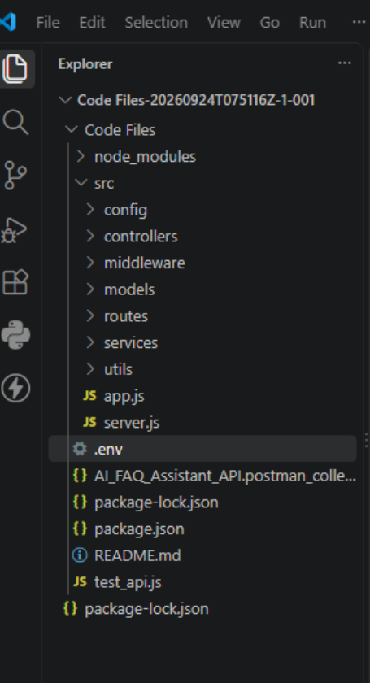
Admin
↓
Manage Users →Manage FAQs →Manage Categories →Monitor AI-generated
Content
OUTPUT:

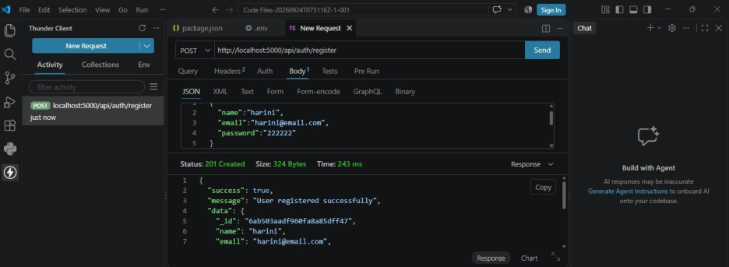
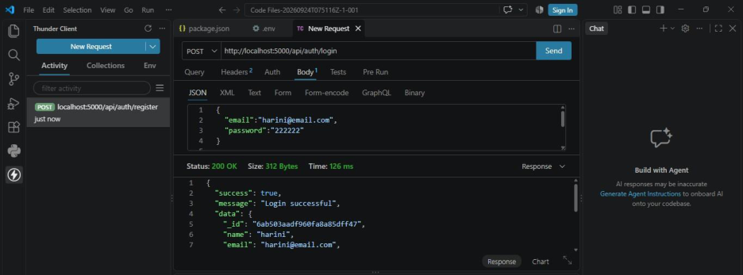
PROJECT EXECUTION:
User Registration: New users can register by providing their name, email, and
password.
Successful Registration: The API validates the request and returns a 201 Created
response with a “User registered successfully” message.
User Login: Registered users can log in using their registered email and password.
Successful Login: The API returns 200 OK with a “Login successful” message
and user details after successful authentication.

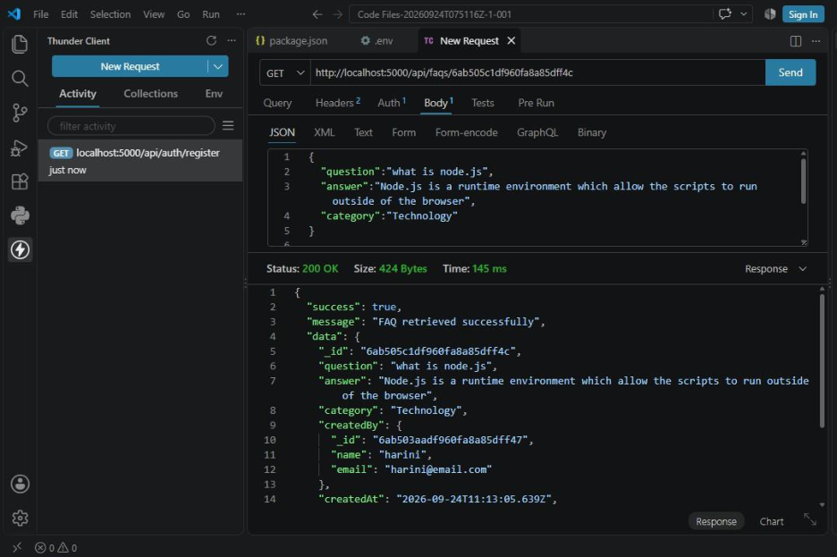
FAQ Retrieval: The GET API retrieves a specific FAQ using its FAQ ID and
displays the question, answer, and category.
Successful Response: The API returns 200 OK with the message “FAQ retrieved
successfully” along with the FAQ details.

FAQ Deletion: The DELETE API removes the selected FAQ using its FAQ ID.
Successful Deletion: The API returns 200 OK with the message “FAQ deleted
successfully”, confirming that the FAQ was deleted.
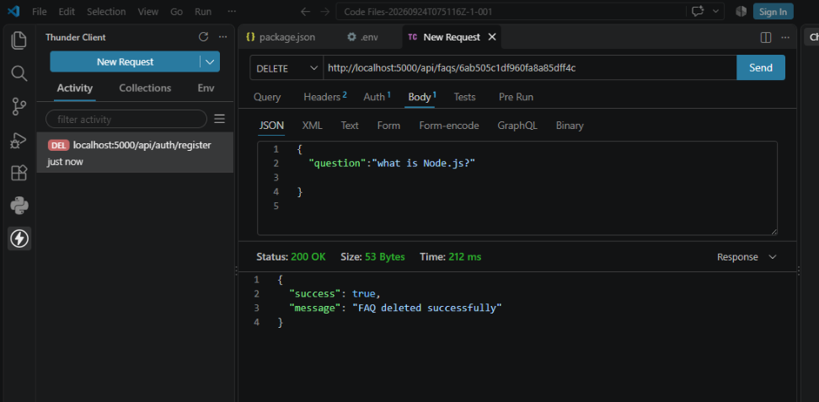

DemoVideoLink: https://drive.google.com/file/d/1G5QvSjCseKnsD_lYsVh8Bh70My8XEHs9/view?usp=drive_link
GitHub Link: https://github.com/rajansoundar364-ctrl/API-FAQ-ASSITANT-API.git

